**Task Report Cos30018 Option B**

**B.5: Machine Processing 2**

**Name: Le Bao Nguyen**

**Student Id: 104169837**

1. Importing libraries (From the task B.2):

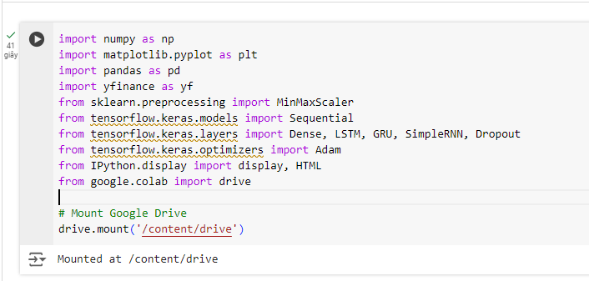

Figure 1: Importing libraries to run the code.

* We still use the same libraries like before.

1. Data loading and processing (From the task B.2):

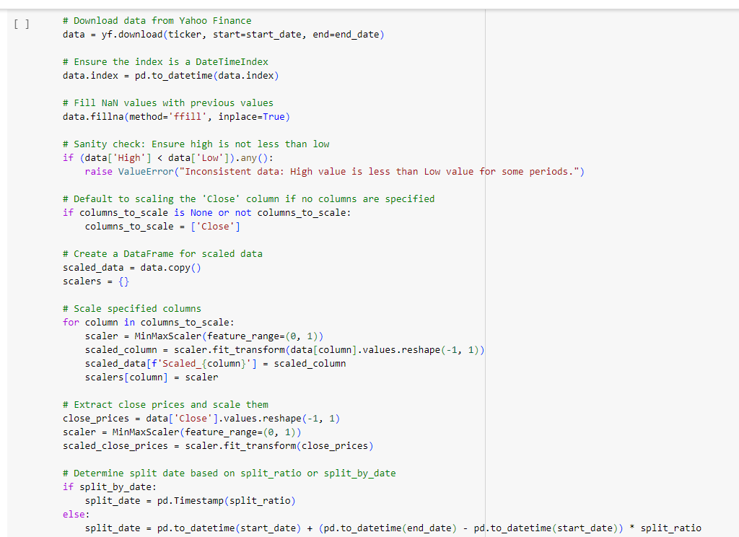

Figure 2: Loading and processing data (1).

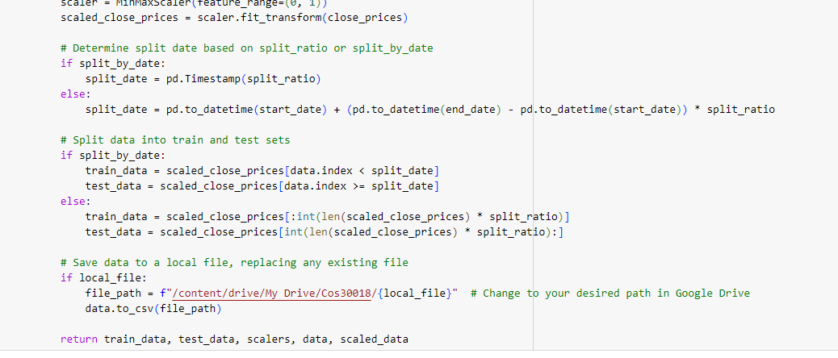

Figure 3: Loading and processing data (2).

* We still use the same data loading and processing just like B.2.

1. Displaying data in a custom table (From the task B.2):

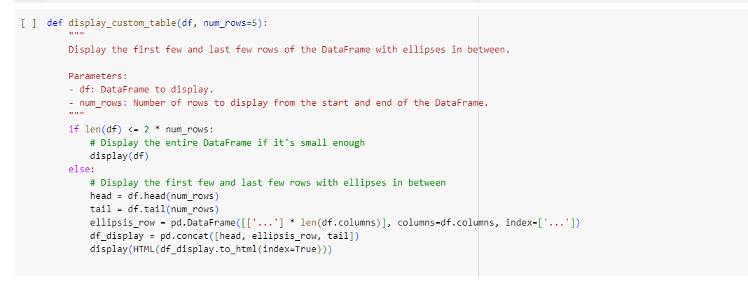

Figure 4: Displaying the data from csv file.

* We still use the same displaying data function just like B.2.

1. Model Creation (From the task B.4):

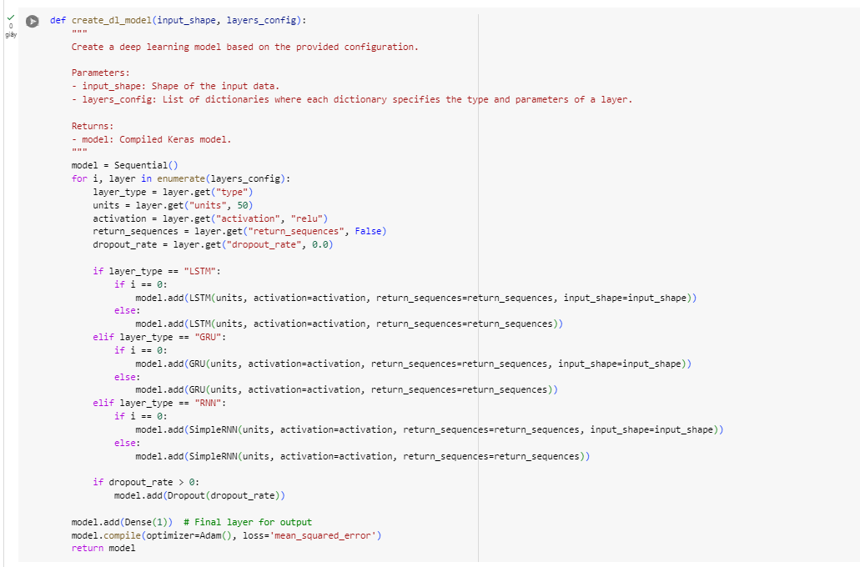Figure 5: Code to create the model.

* We still use the same displaying data function just like B.4.

1. Experimentation with Different Configurations (From the task B.4):

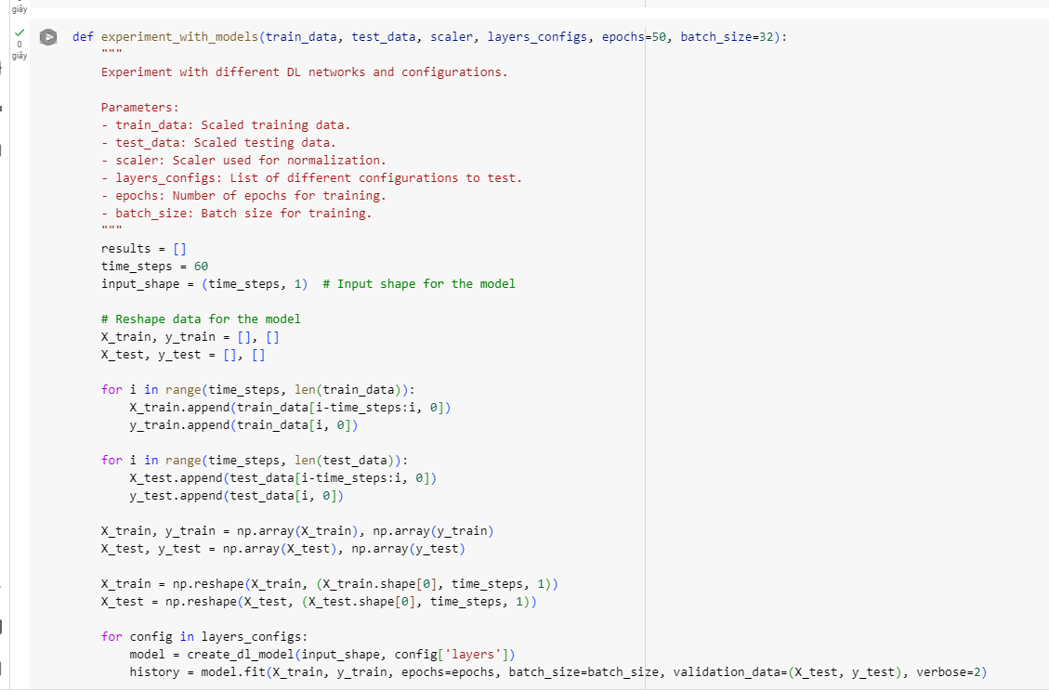

Figure 6: Code to experiment with model (1).

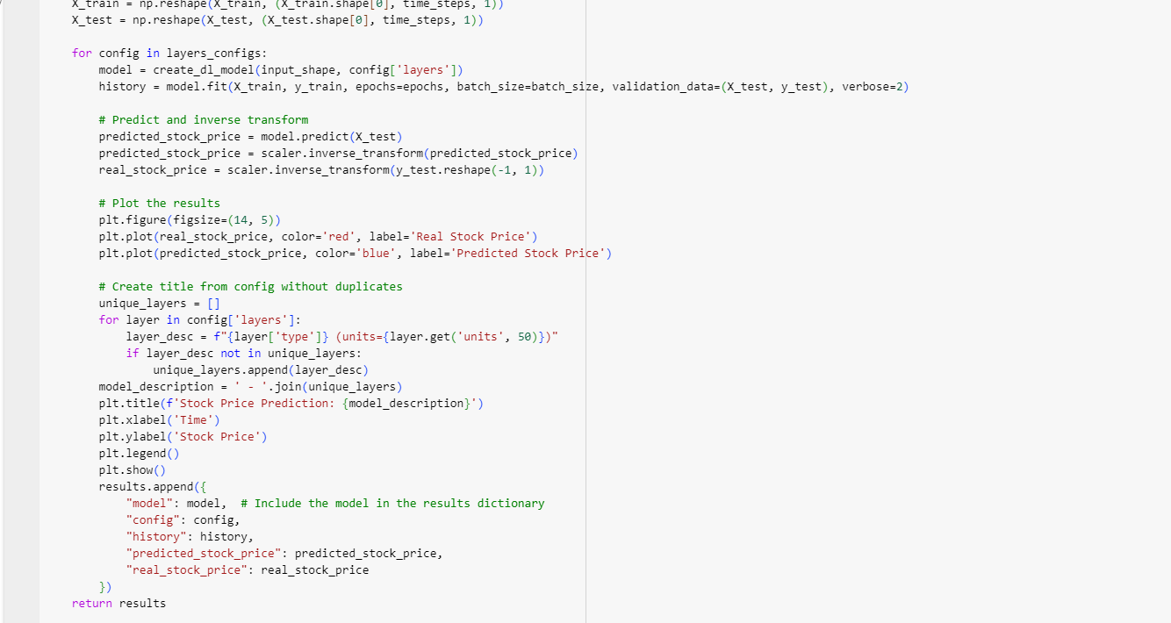

Figure 7: Code to experiment with model (2).

* We still use the same displaying data function just like B.4 but we add the model into the results in the "experiment_with_models" function.

1. Multistep and Multivariate Predictions:

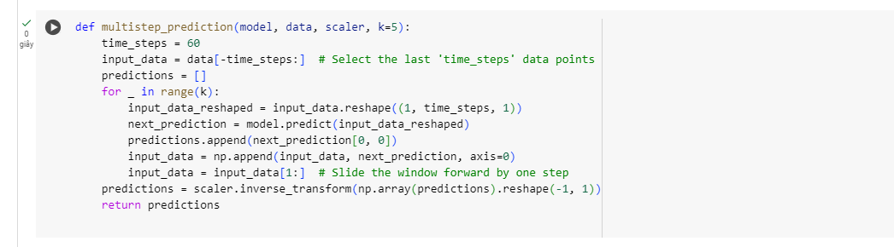

Figure 8: Code to create multistep prediction.

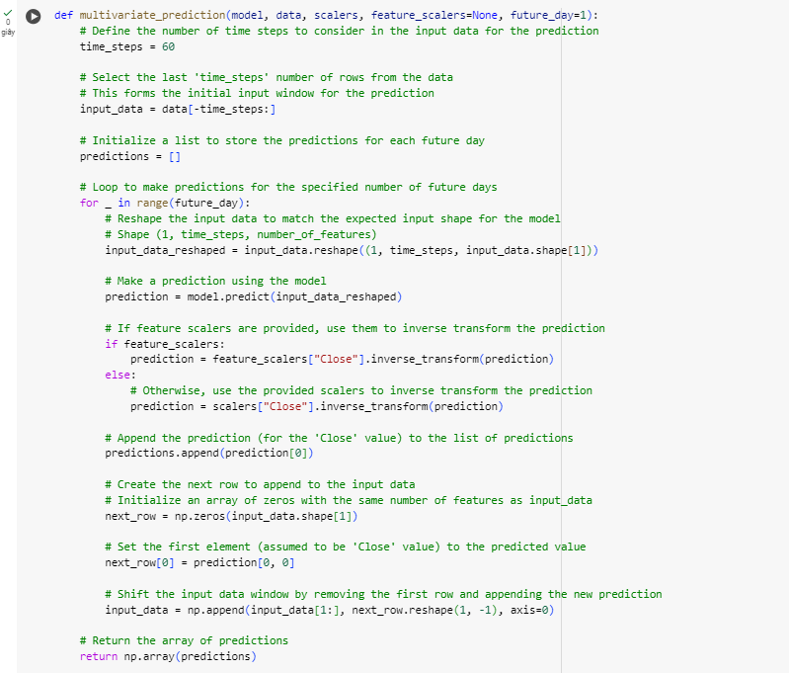

Figure 9: Code to create multivariate prediction.

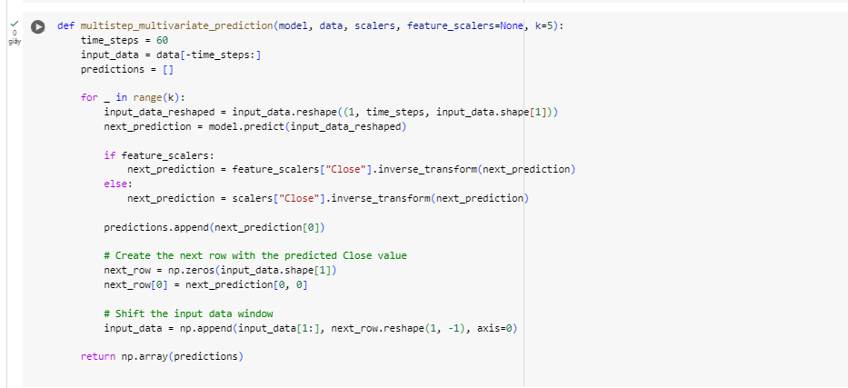

Figure 10: Code to combine multistep and multivariate prediction.

* Multistep prediction:

+ The "multistep_prediction" function forecasts several future time steps via recursive forecasting. With this approach, each future prediction is produced one step at a time, with the prior prediction serving as the basis for the subsequent prediction.

* In a loop that runs k times (where k is the number of future steps to predict), the function reshapes the input data to match the model's expected input shape.
* To keep the same window size, the oldest value in the input data is deleted and the projected value is attached to the input data.
* Using the reshaped input data, the model predicts the value of the next step.
* Multivariate prediction:

+ Multiple feature prediction at once is handled by the "multivariate_prediction" function. This method provides an improved prediction model by taking into account the interdependencies between multiple features.

* The input data is reshaped to match the model's expected input shape, which includes the number of time steps and the number of features.
* The last "time_steps" points are selected from the dataset by the function to prepare the input data. There are several characteristics in this input data.
* The model predicts the future value(s) based on the reshaped input data.
* Multistep Multivariate Prediction:

+ Combining the ideas of multistep and multivariate predictions, the "multistep_multivariate_prediction" function makes predictions for several future time steps while taking into account different features.

* In a loop that runs k times (where k is the number of future steps to predict), the function reshapes the input data to match the model's expected input shape.
* The model predicts the next time step's value(s) based on the reshaped input data.
* To keep a constant window size, the projected values are added to the input data and the oldest values are removed.
* When there are several features, the function makes sure that the interdependencies between the features are maintained and the input data is updated properly.

1. Main script run:

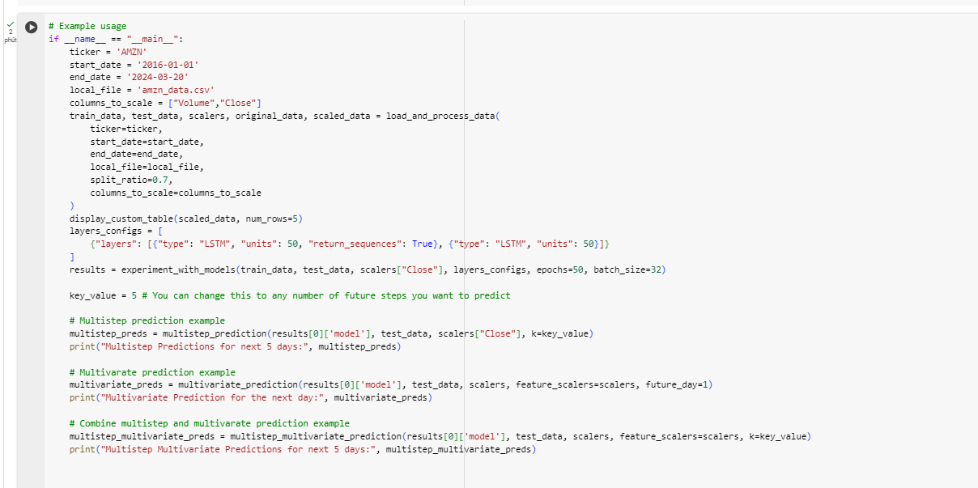

Figure 11: The script to run the code and the prediction.

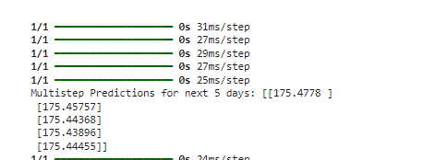

Figure 12: The multistep prediction results for the next 5 days.



Figure 13: The multivariate prediction results for the next day.

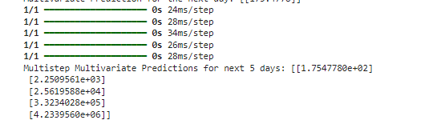

Figure 14: The multistep multivariate prediction results for the next 5 days.

1. References:

HURSON, T. (2021). Stock Price Prediction with LSTM/Multi-Step LSTM. <https://www.kaggle.com/code/thibauthurson/stock-price-prediction-with-lstm-multi-step-lstm>